Tela de atualização de fornecedor

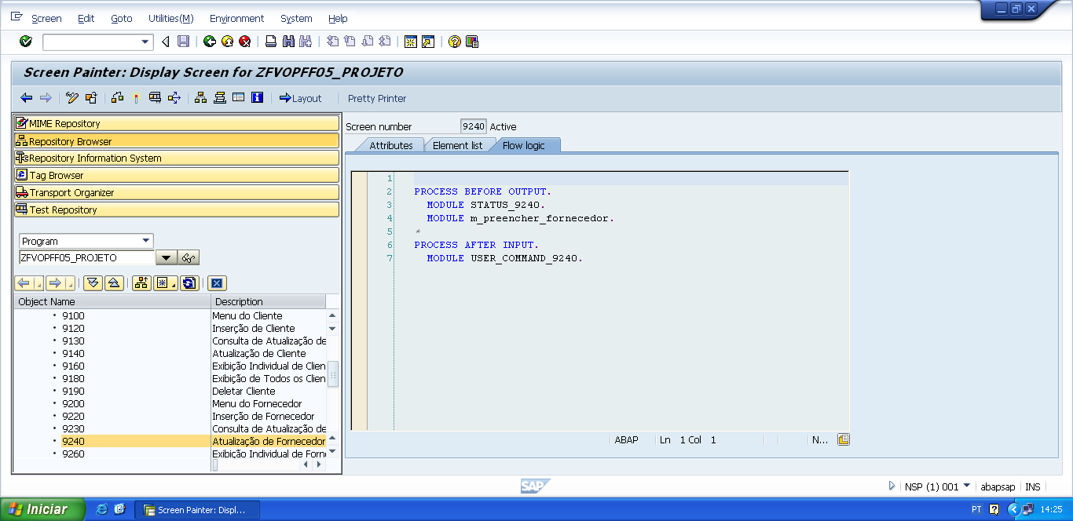

PROCESS BEFORE OUTPUT.  
  MODULE STATUS_9240.  
   MODULE m_preencher_fornecedor.

*&---------------------------------------------------------------------*  
*&      Module  STATUS_9240  OUTPUT  
*&---------------------------------------------------------------------*  
*       text  
*----------------------------------------------------------------------*  
MODULE status_9240 OUTPUT.  
  SET PF-STATUS 'STATUS9240'.  
  SET TITLEBAR 'TITULO9240'.  
  
ENDMODULE.                 " STATUS_9240  OUTPUT

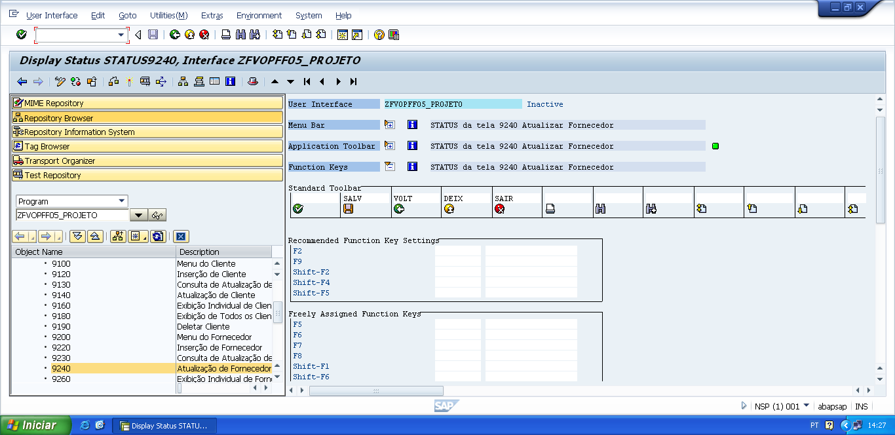

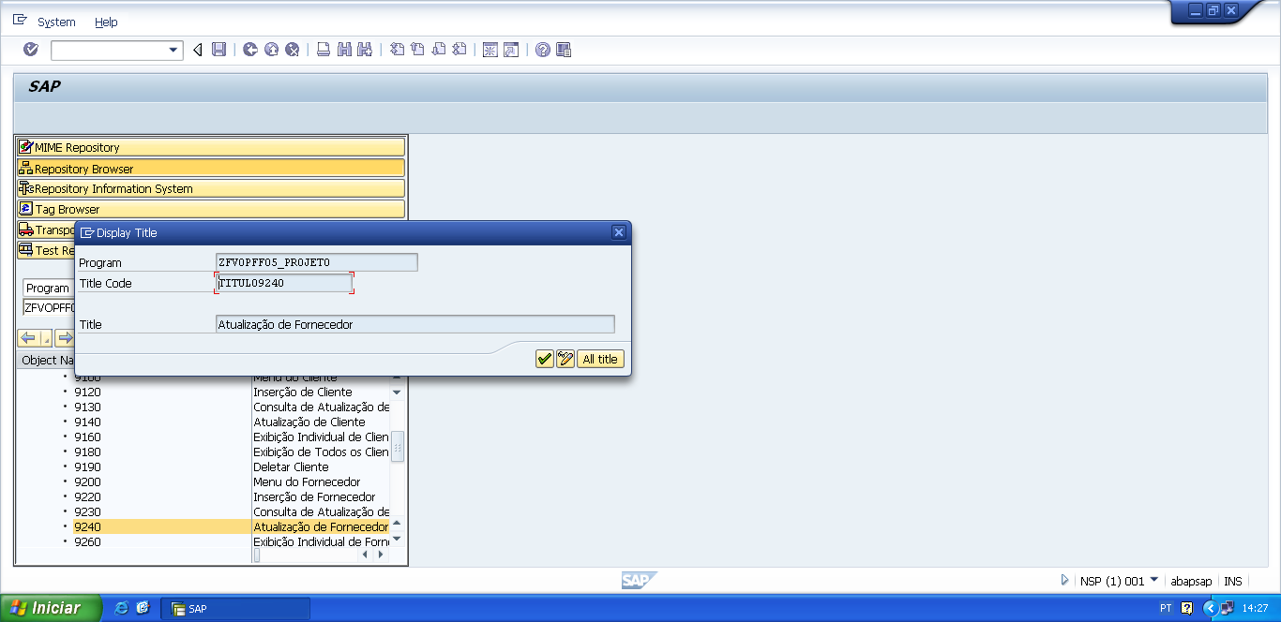

*&---------------------------------------------------------------------*  
*&      Module  M_PREENCHER_FORNECEDOR  OUTPUT  
*&---------------------------------------------------------------------*  
*       text  
*----------------------------------------------------------------------*  
module M_PREENCHER_FORNECEDOR output.  
  
PERFORM f_preencher_fornecedor.  
  
endmodule.                 " M_PREENCHER_FORNECEDOR  OUTPUT

*&---------------------------------------------------------------------*  
*&      Form  F_PREENCHER_FORNECEDOR  
*&---------------------------------------------------------------------*  
*       text  
*----------------------------------------------------------------------*  
*  -->  p1        text  
*  <--  p2        text  
*----------------------------------------------------------------------*  
FORM f_preencher_fornecedor .  
  
  v_cnpj_forn     = wa_zfvtpff05_fornec-cnpj_fornecedor.  
  v_nome_forn     = wa_zfvtpff05_fornec-nome_fornecedor.  
  v_end_forn      = wa_zfvtpff05_fornec-end_fornecedor.  
  v_tel_pri_forn  = wa_zfvtpff05_fornec-tel01_fornecedor.  
  v_tel_sec_forn  = wa_zfvtpff05_fornec-tel02_fornecedor.  
  
ENDFORM.                    " F_PREENCHER_FORNECEDOR

PROCESS AFTER INPUT.  
   MODULE USER_COMMAND_9240.

*&---------------------------------------------------------------------*  
*&      Module  USER_COMMAND_9240  INPUT  
*&---------------------------------------------------------------------*  
*       text  
*----------------------------------------------------------------------*  
MODULE user_command_9240 INPUT.  
  
  v_okcode = sy-ucomm.  
  
  CASE v_okcode.  
    WHEN 'VOLT'.  
      PERFORM f_voltar.  
    WHEN 'DEIX'.  
      PERFORM f_deixar.  
    WHEN 'SAIR'.  
      PERFORM f_sair.  
    WHEN 'SALV'.  
      PERFORM f_salvar_atu_fornecedor.  
*  
    WHEN 'SAF4'.  
      PERFORM f_salvar_atu_fornecedor.  
  ENDCASE.  
  
  CLEAR v_okcode.  
ENDMODULE.                 " USER_COMMAND_9240  INPUT

*&---------------------------------------------------------------------*  
*&      Form  F_VOLTAR  
*&---------------------------------------------------------------------*  
* FORM de voltar, serve para voltar automaticamente para a tela  
*anterior da tela atual.  
*----------------------------------------------------------------------*  
*  -->  p1        text  
*  <--  p2        text  
*----------------------------------------------------------------------*  
FORM f_voltar.  
  
*Volte para á tela 9000 (Tela Principal)  
*ou  
**CALL SCREEN '9000'.**  
  PERFORM f_limpar_variaveis.  
  SET SCREEN 0.  
  LEAVE SCREEN.  
  
  
ENDFORM.                    " F_VOLTAR  
  
*&---------------------------------------------------------------------*  
*&      Form  F_DEIXAR  
*&---------------------------------------------------------------------*  
*       text  
*----------------------------------------------------------------------*  
*  -->  p1        text  
*  <--  p2        text  
*----------------------------------------------------------------------*  
FORM f_deixar .  
  
  LEAVE LIST-PROCESSING.  
  
ENDFORM.                    " F_DEIXAR  
  
*&---------------------------------------------------------------------*  
*&      Form  F_SAIR  
*&---------------------------------------------------------------------*  
*       text  
*----------------------------------------------------------------------*  
*  -->  p1        text  
*  <--  p2        text  
*----------------------------------------------------------------------*  
FORM f_sair.  
  
  LEAVE LIST-PROCESSING.  
  
ENDFORM.                    " F_SAIR

*&---------------------------------------------------------------------*  
*&      Form  F_SALVAR_FORNECEDOR  
*&---------------------------------------------------------------------*  
*       text  
*----------------------------------------------------------------------*  
*  -->  p1        text  
*  <--  p2        text  
*----------------------------------------------------------------------*  
FORM f_salvar_atu_fornecedor.  
  
  UPDATE zfvtpff05_fornec  
       SET  cnpj_fornecedor  = v_cnpj_forn  
            nome_fornecedor  = v_nome_forn  
            end_fornecedor   = v_end_forn  
            tel01_fornecedor = v_tel_pri_forn  
            tel02_fornecedor = v_tel_sec_forn  
       WHERE cnpj_fornecedor = v_cnpj_forn.  
  
  IF sy-subrc IS INITIAL.  
  
    MESSAGE s003(zfvclpff05).  
    PERFORM f_limpar_variaveis.  
    CALL SCREEN '9230'.  
  
  ELSE.  
  
    MESSAGE s004(zfvclpff05) DISPLAY LIKE 'E'.  
  
  ENDIF.  
  
ENDFORM.                    " F_SALVAR_FORNECEDOR